**Update Album API**

**Add below code in AlbumController.java**

//Update Album

    @PutMapping(value = "/albums/{album_id}/update", consumes = "application/json", produces = "application/json")

    @ResponseStatus(HttpStatus.CREATED)

    @ApiResponse(responseCode = "400", description = "Please add valid name a description")

    @ApiResponse(responseCode = "204", description = "Album update")

    @Operation(summary = "Update an Album")

    @SecurityRequirement(name = "studyeasy-demo-api")

    public ResponseEntity<AlbumViewDTO> update_Album(@Valid @RequestBody AlbumPayloadDTO albumPayloadDTO,

            @PathVariable long album_id, Authentication authentication) {

        try {

            String email = authentication.getName();

            Optional<Account> optionalAccount = accountService.findByEmail(email);

            Account account = optionalAccount.get();

            Optional<Album> optionaAlbum = albumService.findById(album_id);

            Album album;

            if (optionaAlbum.isPresent()) {

                album = optionaAlbum.get();

                if (account.getId() != album.getAccount().getId()) {

                    return ResponseEntity.status(HttpStatus.FORBIDDEN).body(null);

                }

            } else {

                return ResponseEntity.status(HttpStatus.BAD_REQUEST).body(null);

            }

            album.setName(albumPayloadDTO.getName());

            album.setDescription(albumPayloadDTO.getDescription());

            album = albumService.save(album);

            List<PhotoDTO> photos = new ArrayList<>();

            for(Photo photo: photoService.findByAlbumId(album.getId())){

                String link = "/albums/"+album.getId()+"/photos/"+photo.getId()+"/download-photo";

                photos.add(new PhotoDTO(photo.getId(), photo.getName(), photo.getDescription(),

                photo.getFileName(), link));

            }

            AlbumViewDTO albumViewDTO = new AlbumViewDTO(album.getId(), album.getName(), album.getDescription(), photos);

            return ResponseEntity.ok(albumViewDTO);

        } catch (Exception e) {

            return ResponseEntity.status(HttpStatus.BAD_REQUEST).body(null);

        }

    }

**Output**

**Token Generated to authrozie for user**

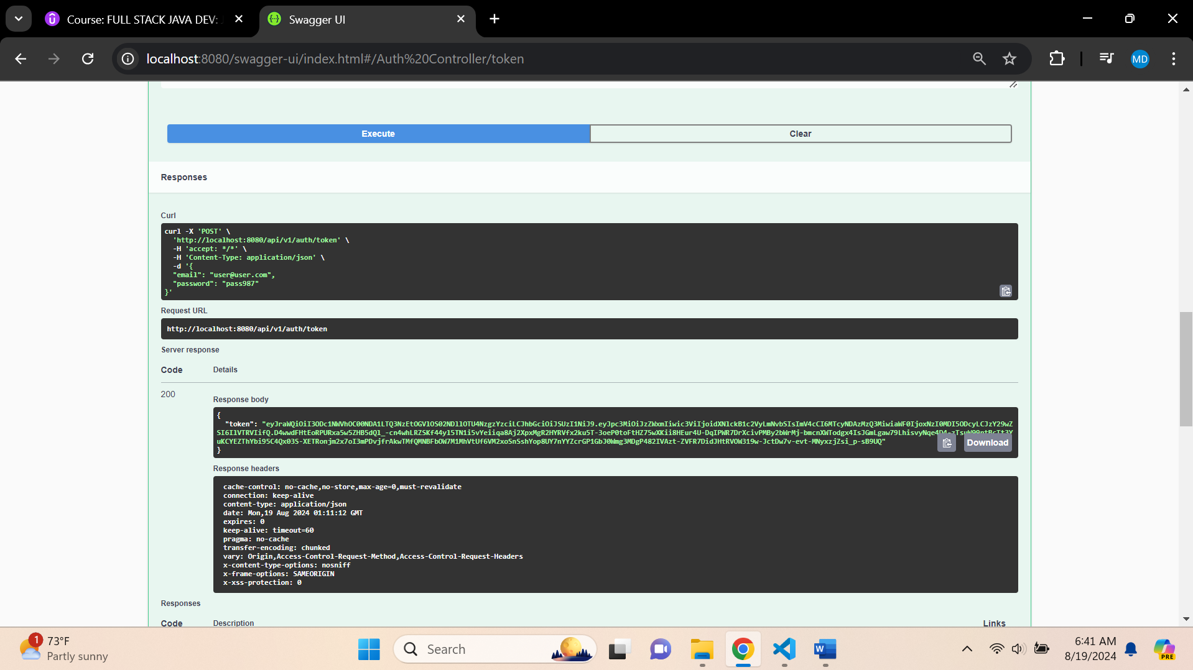

**List of Albums - Starting**

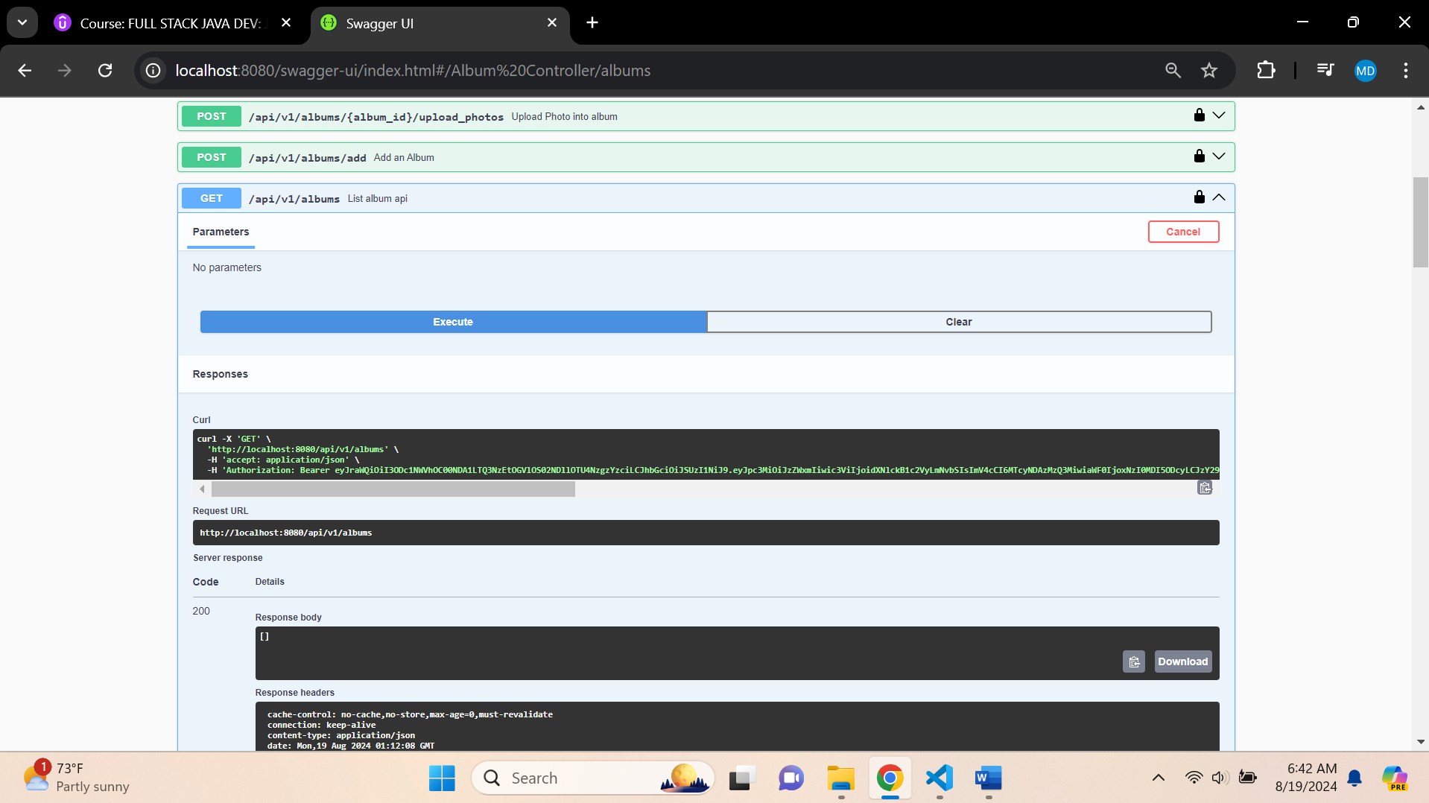

**Add Album – More than 2**

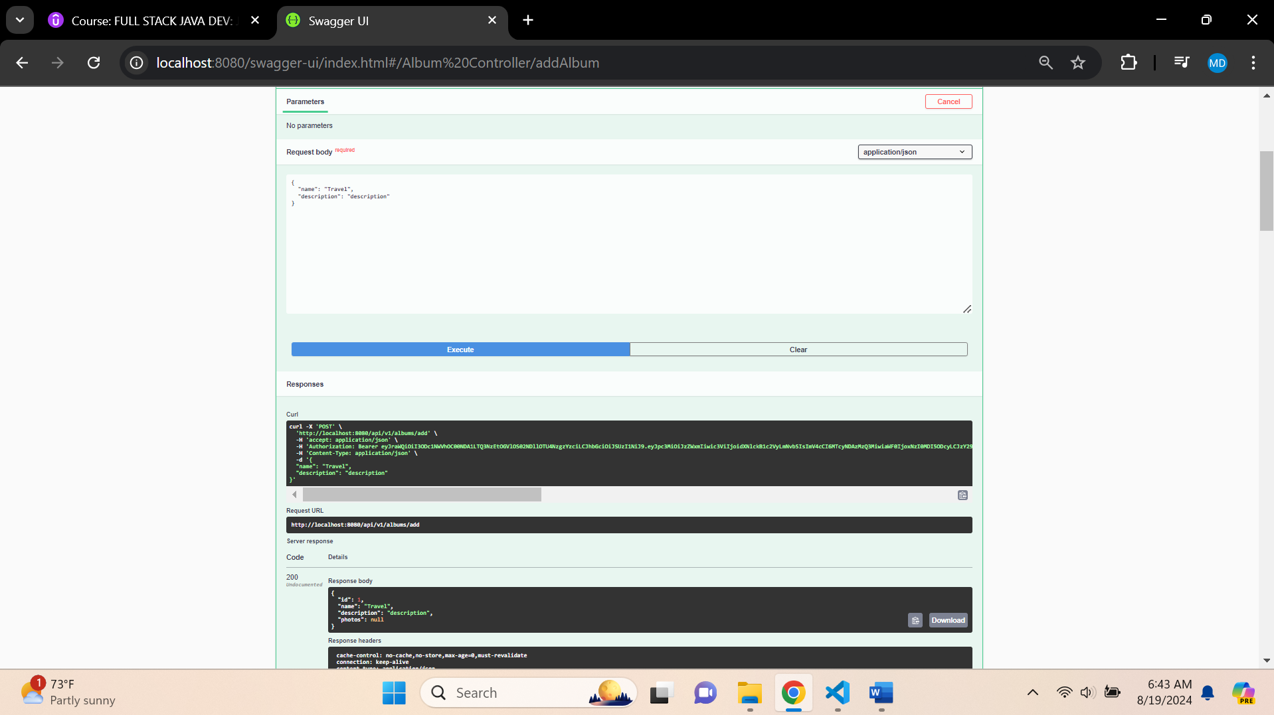

**List of Albums with no photo uploaded**

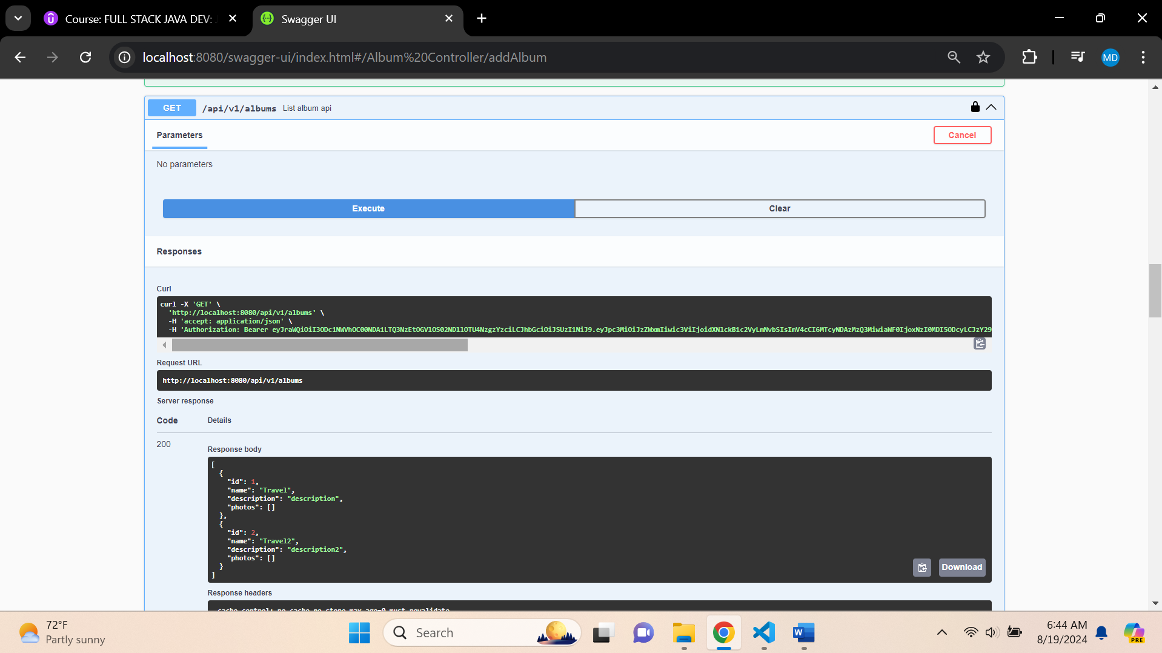

**Updating Photo into album (id =2)**

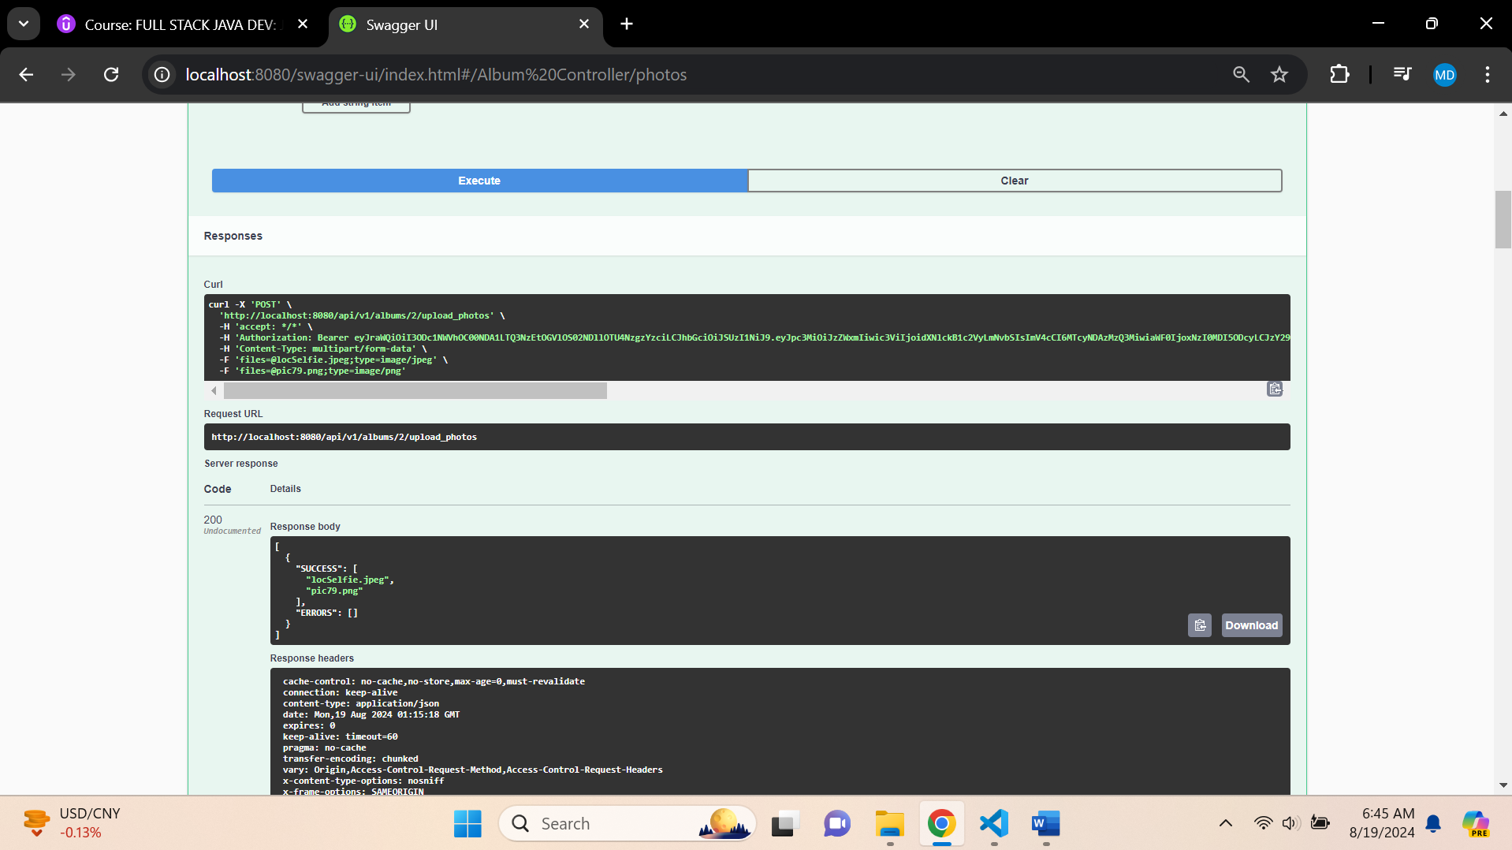

**List of Albums with photo uploaded – id = 2**

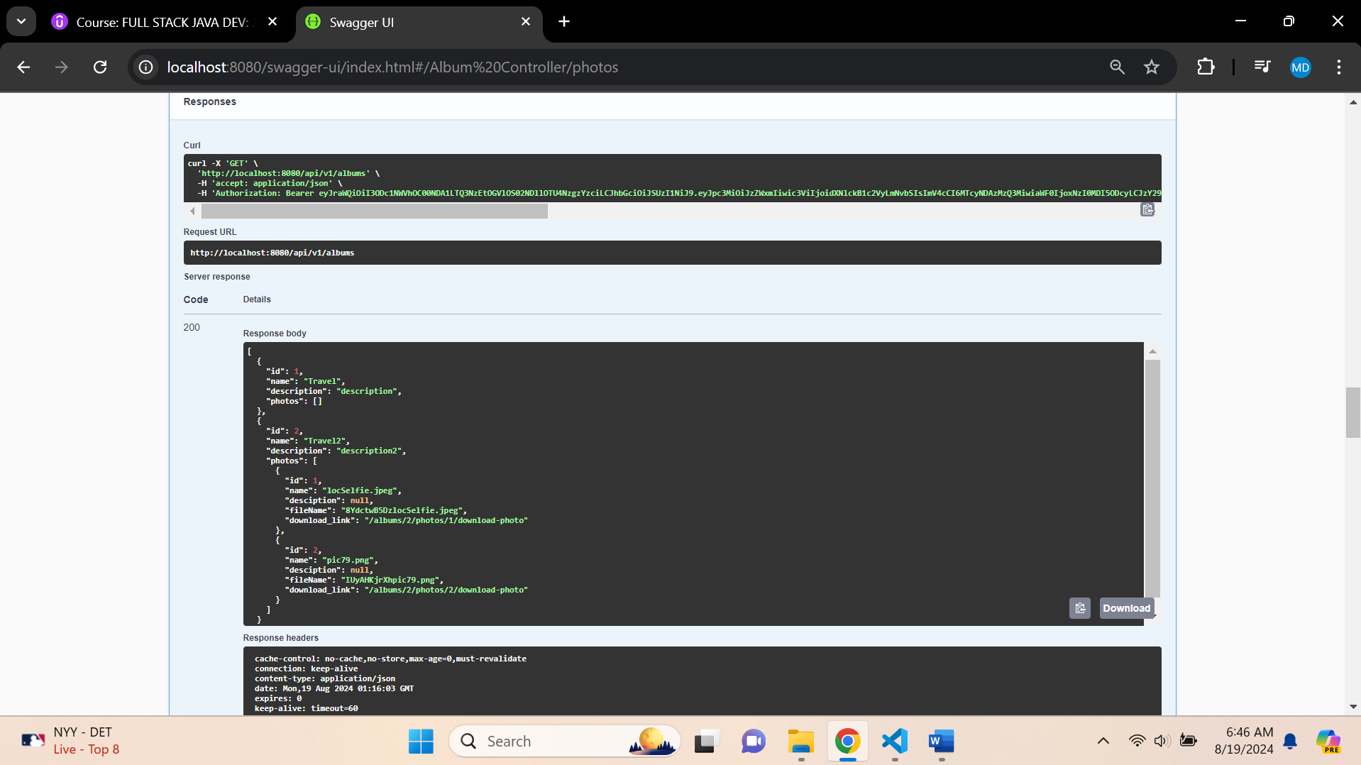

**List album by album id**

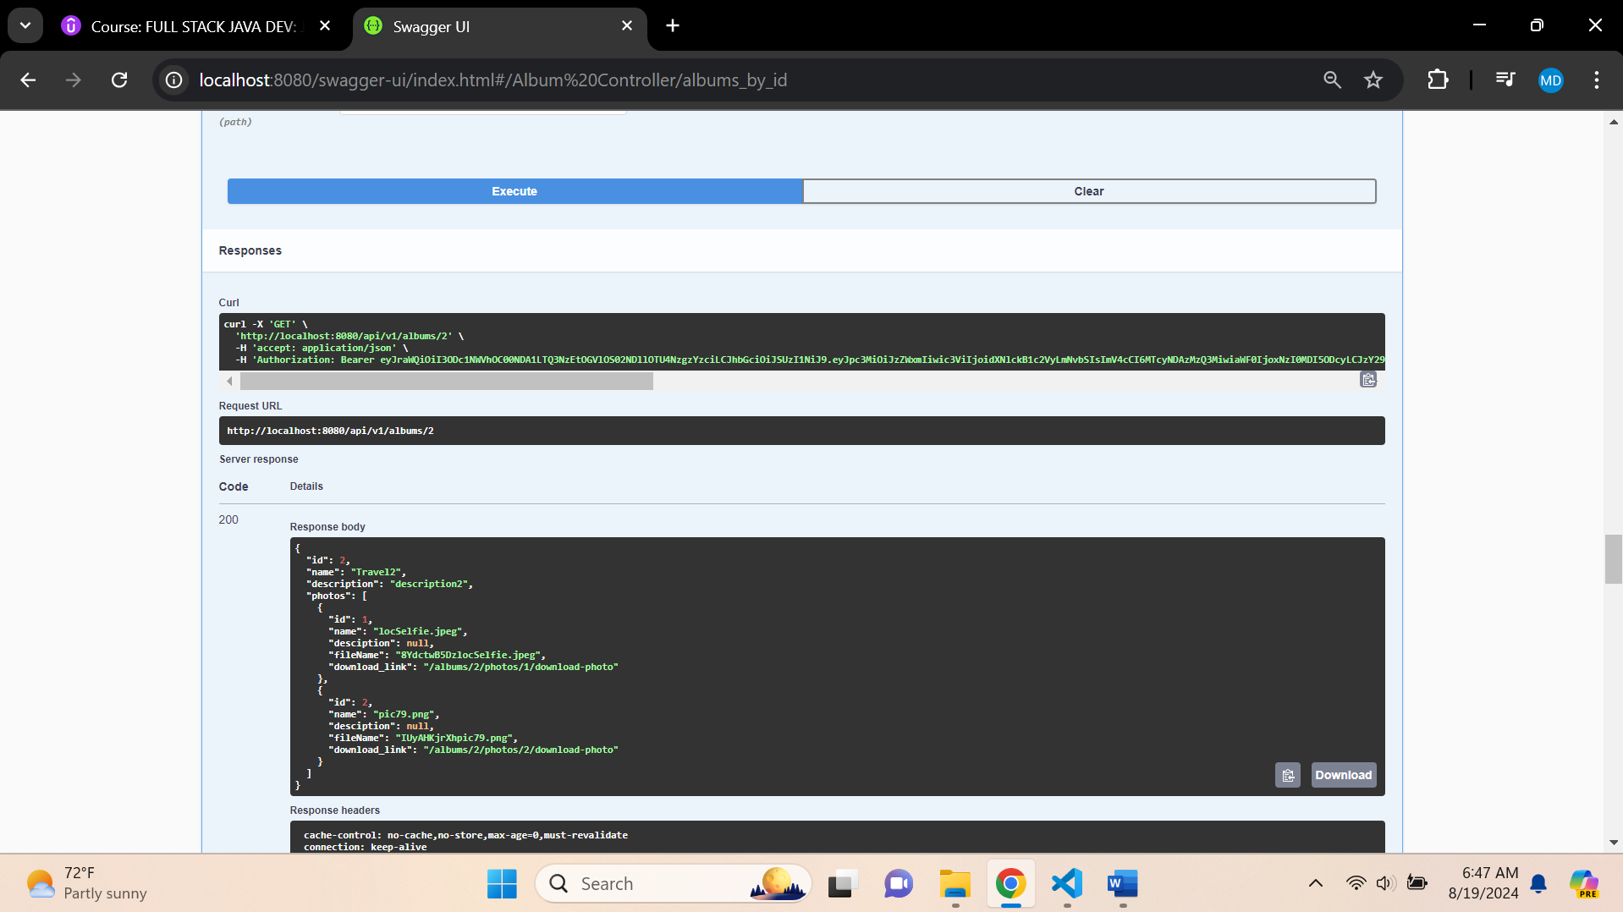

**Updating Album**

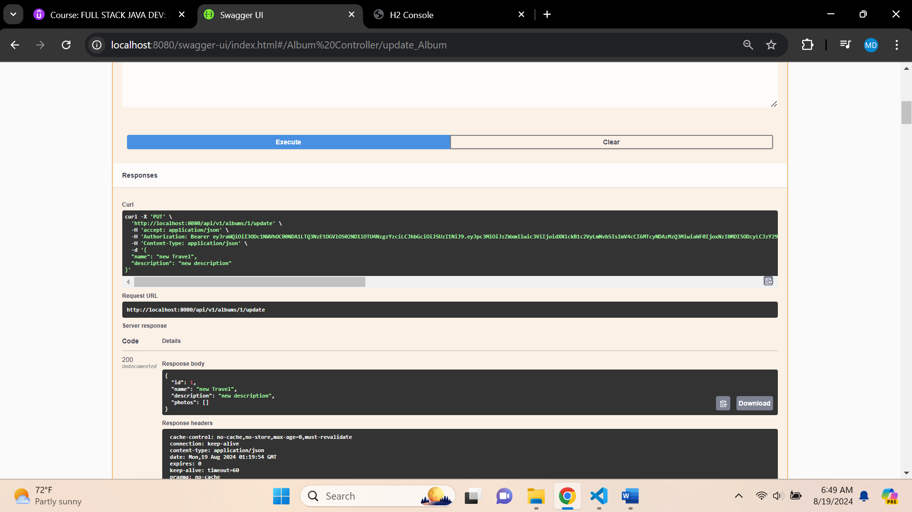

**Db Console – Album – Before Update**

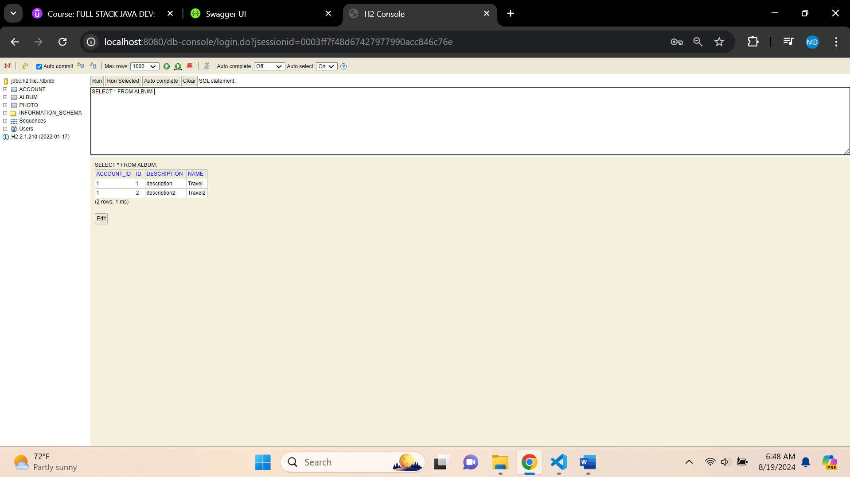

**Db Console – Album – After Update**

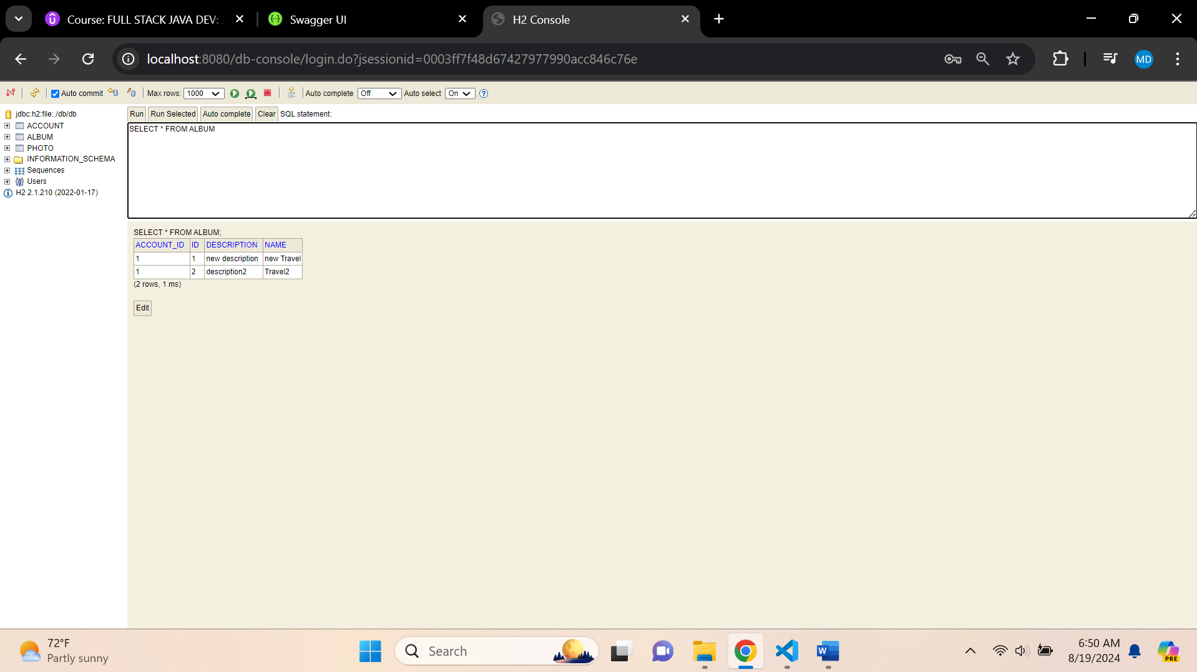



**Final Frontend API Swagger View for AlbumController**

